VISVESVARAYA TECHNOLOGICAL UNIVERSITY
“JnanaSangama”, Belgaum -590014, Karnataka.

LAB RECORD
Bio Inspired Systems (23CS5BSBIS)
Submitted by
Sushma B T(1WA23CS002)
in partial fulfillment for the award of the degree of
BACHELOR OF ENGINEERING
in
COMPUTER SCIENCE AND ENGINEERING

B.M.S. COLLEGE OF ENGINEERING
(Autonomous Institution under VTU)
BENGALURU-560019
Aug-2025 to Dec-2025
B.M.S. College of Engineering,
Bull Temple Road, Bangalore 560019
(Affiliated To Visvesvaraya Technological University, Belgaum)

Department of Computer Science and Engineering
CERTIFICATE
This is to certify that the Lab work entitled “ Bio Inspired Systems (23CS5BSBIS)” carried out by Sushma B T (1WA23CS002), who is bonafide student of B.M.S. College of Engineering. It is in partial fulfillment for the award of Bachelor of Engineering in Computer Science and Engineering of the Visvesvaraya Technological University, Belgaum. The Lab report has been approved as it satisfies the academic requirements of the above mentioned subject and the work prescribed for the said degree.

 | Shwetha KS |  |  | Dr. Kavitha Sooda  Professor & HOD  Department of CSE, BMSCE
 | Assistant Professor  Department of CSE, BMSCE |  |  | Dr. Kavitha Sooda  Professor & HOD  Department of CSE, BMSCE

Index
Sl.  No. | Date | Experiment Title | Page No.
1 | 14/8/25 | Genetic Algorithm for Optimization Problems | 1-9
2 | 21/8/25 | Optimization via Gene Expression Algorithms | 10-16
3 | 28/8/25 | Particle Swarm Optimization for Function Optimization | 17-23
4 | 11/9/25 | Ant Colony Optimization for the Traveling Salesman Problem: | 24-30
5 | 9/10/25 | Cuckoo Search (CS) | 31-37
6 | 6/11/25 | Grey Wolf Optimizer (GWO) | 38-44
7 | 13/11/25 | Parallel Cellular Algorithms and Programs | 45-52

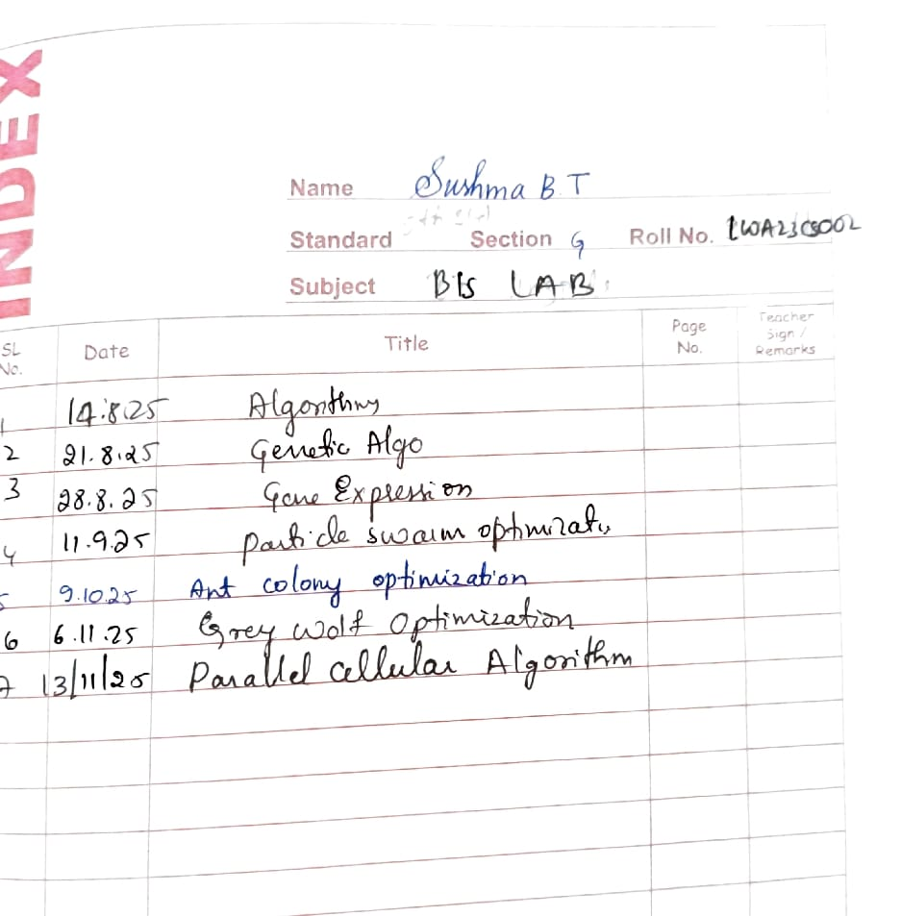

Github Link:
https://github.com/Sushmabt680/BIS
Program 1Genetic Algorithms (GA) are inspired by the process of natural selection and genetics, where the fittest individuals are selected for reproduction to produce the next generation. GAs are widely used for solving optimization and search problems. Implement a Genetic Algorithm using Python to solve a basic optimization problem, such as finding the maximum value of a mathematical function.

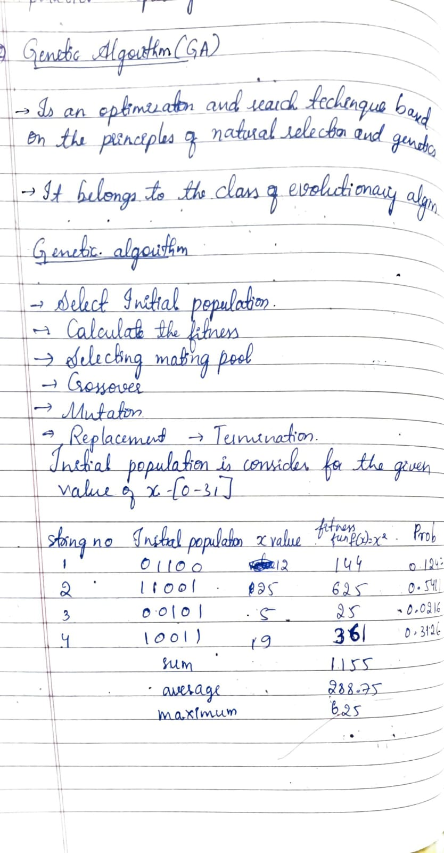
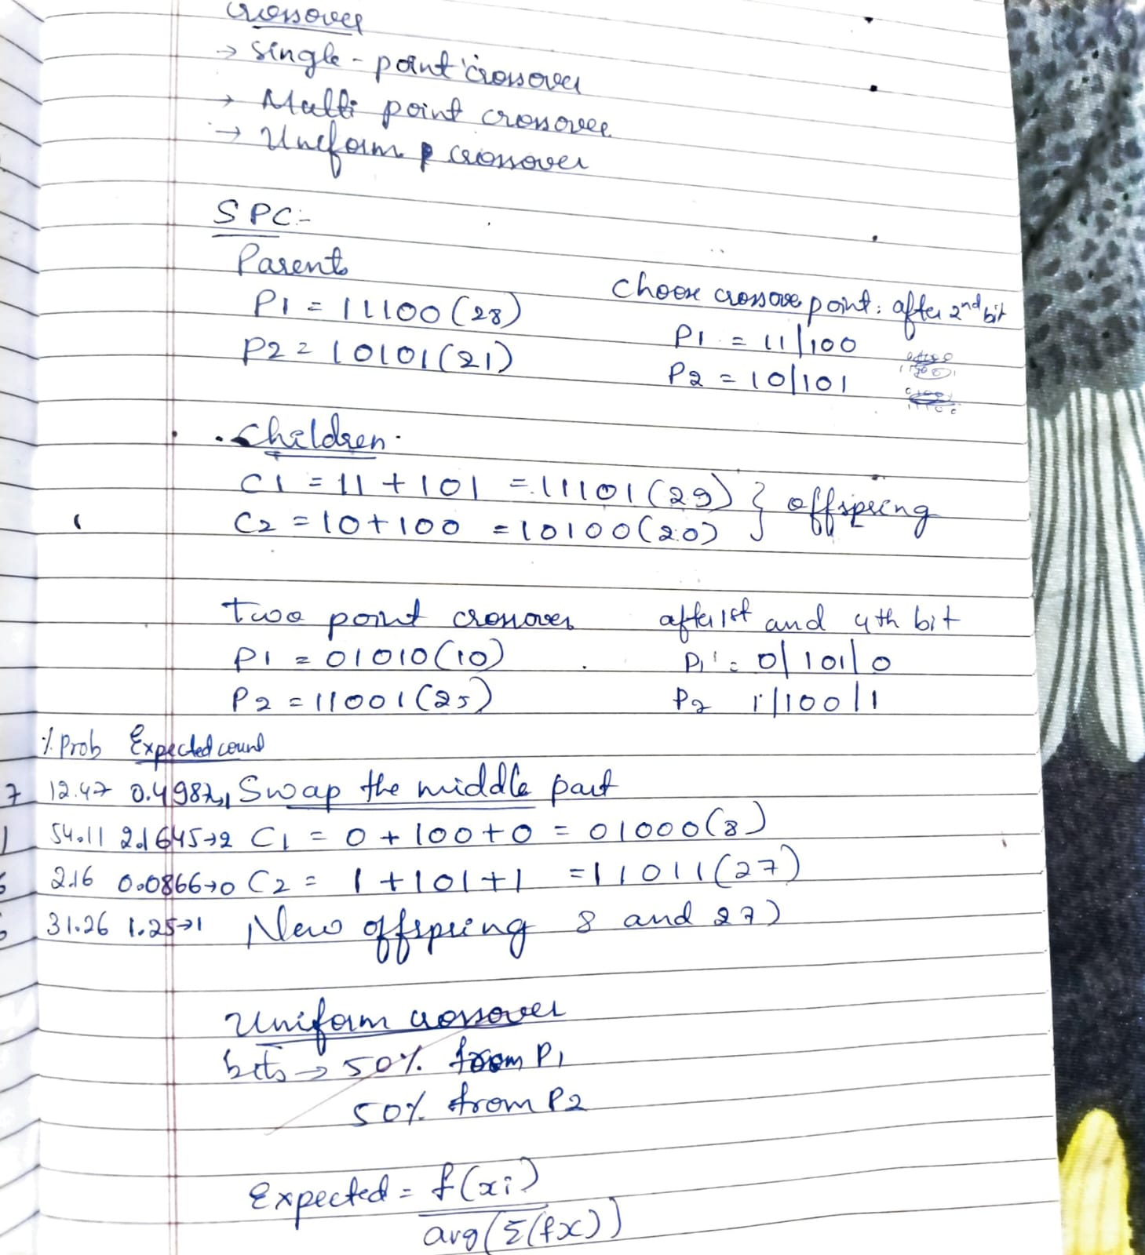
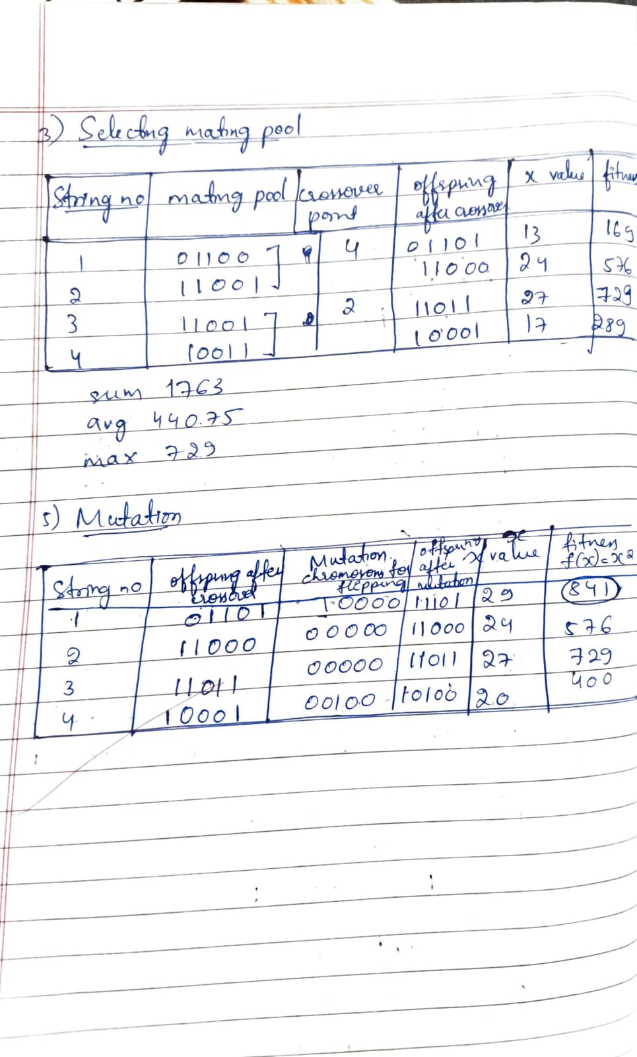
Code:
import random

CHROM_LENGTH = 5
CROSS_RATE = 0.8
MUT_RATE = 0.1

def fitness(x):
return x**2

def encode(x):
return format(x, f'0{CHROM_LENGTH}b')

def decode(b):
return int(b, 2)

def roulette_selection(pop, fitnesses):
total_fit = sum(fitnesses)
pick = random.uniform(0, total_fit)
current = 0
for i, f in enumerate(fitnesses):
current += f
if current > pick:
return pop[i]
return pop[-1]

def crossover(p1, p2):
if random.random() < CROSS_RATE:
point = random.randint(1, CHROM_LENGTH-1)
c1 = p1[:point] + p2[point:]
c2 = p2[:point] + p1[point:]
return c1, c2
return p1, p2

def mutate(chrom):
chrom_list = list(chrom)
for i in range(CHROM_LENGTH):
if random.random() < MUT_RATE:
chrom_list[i] = '1' if chrom_list[i] == '0' else '0'
return ''.join(chrom_list)

def genetic_algorithm():
user_input = input("Enter initial population values (space-separated, e.g. 12 23 5 19): ")
values = list(map(int, user_input.split()))
generations = int(input("Enter number of generations to run: "))

POP_SIZE = len(values)
population = [encode(x) for x in values]

print("\nInitial Population:", population, [decode(c) for c in population])

global_best = population[0]
global_best_fit = fitness(decode(global_best))

for gen in range(1, generations + 1):
decoded = [decode(c) for c in population]
fitnesses = [fitness(x) for x in decoded]

best_idx = fitnesses.index(max(fitnesses))
if fitnesses[best_idx] > global_best_fit:
global_best = population[best_idx]
global_best_fit = fitnesses[best_idx]

total_fit = sum(fitnesses)
probs = [f / total_fit for f in fitnesses]
expected = [p * POP_SIZE for p in probs]

print(f"\nGeneration {gen}")
for i in range(POP_SIZE):
print(f"x={decoded[i]}, bin={population[i]}, fit={fitnesses[i]}, "
f"prob={probs[i]:.3f}, exp_count={expected[i]:.2f}")

new_pop = [global_best]

while len(new_pop) < POP_SIZE:
p1 = roulette_selection(population, fitnesses)
p2 = roulette_selection(population, fitnesses)
c1, c2 = crossover(p1, p2)
c1, c2 = mutate(c1), mutate(c2)
new_pop.extend([c1, c2])

population = new_pop[:POP_SIZE]

decoded = [decode(c) for c in population]
fitnesses = [fitness(x) for x in decoded]
best_idx = fitnesses.index(max(fitnesses))
print("\nFinal Best Solution:", decoded[best_idx], population[best_idx], "fitness=", fitnesses[best_idx])

genetic_algorithm()
OUTPUT: 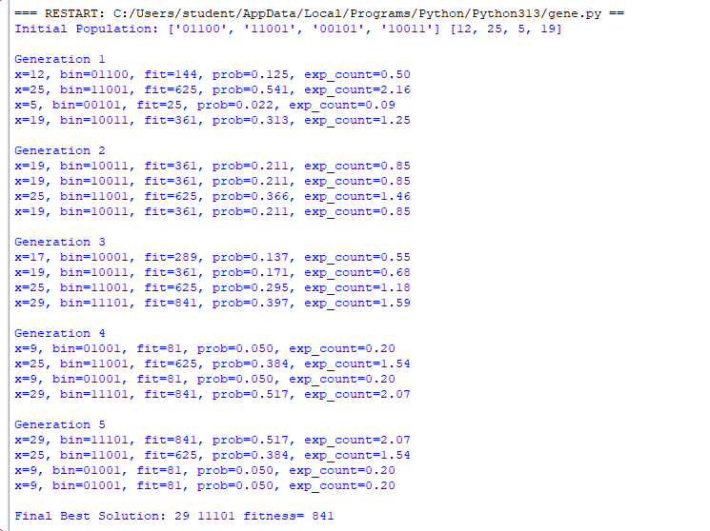

Algorithm: 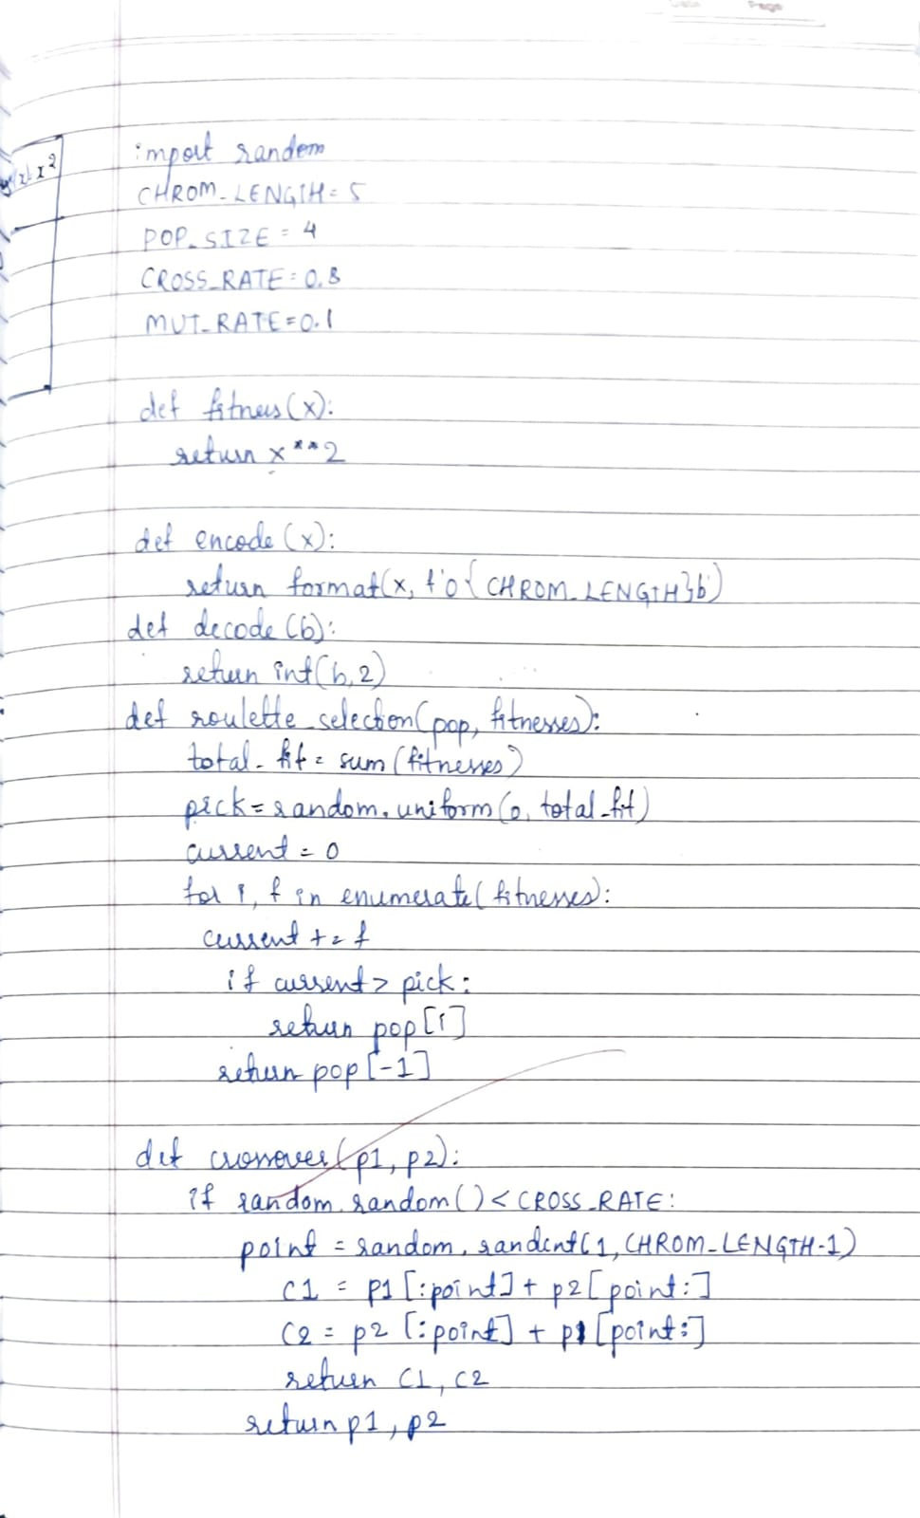

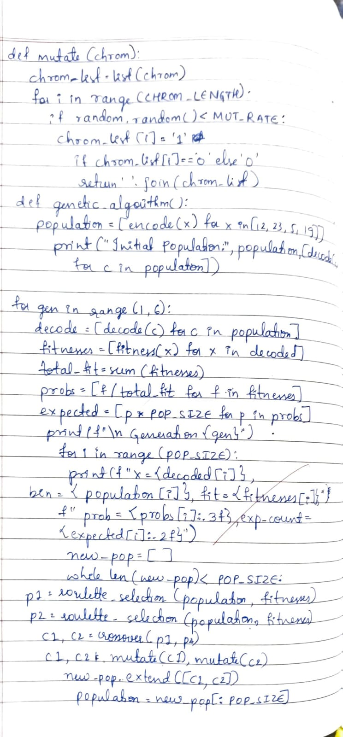

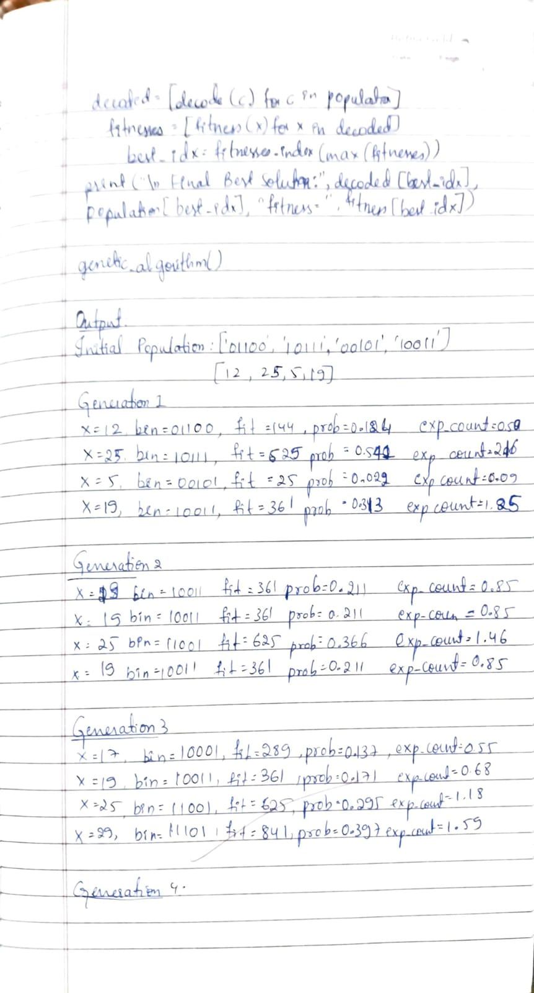
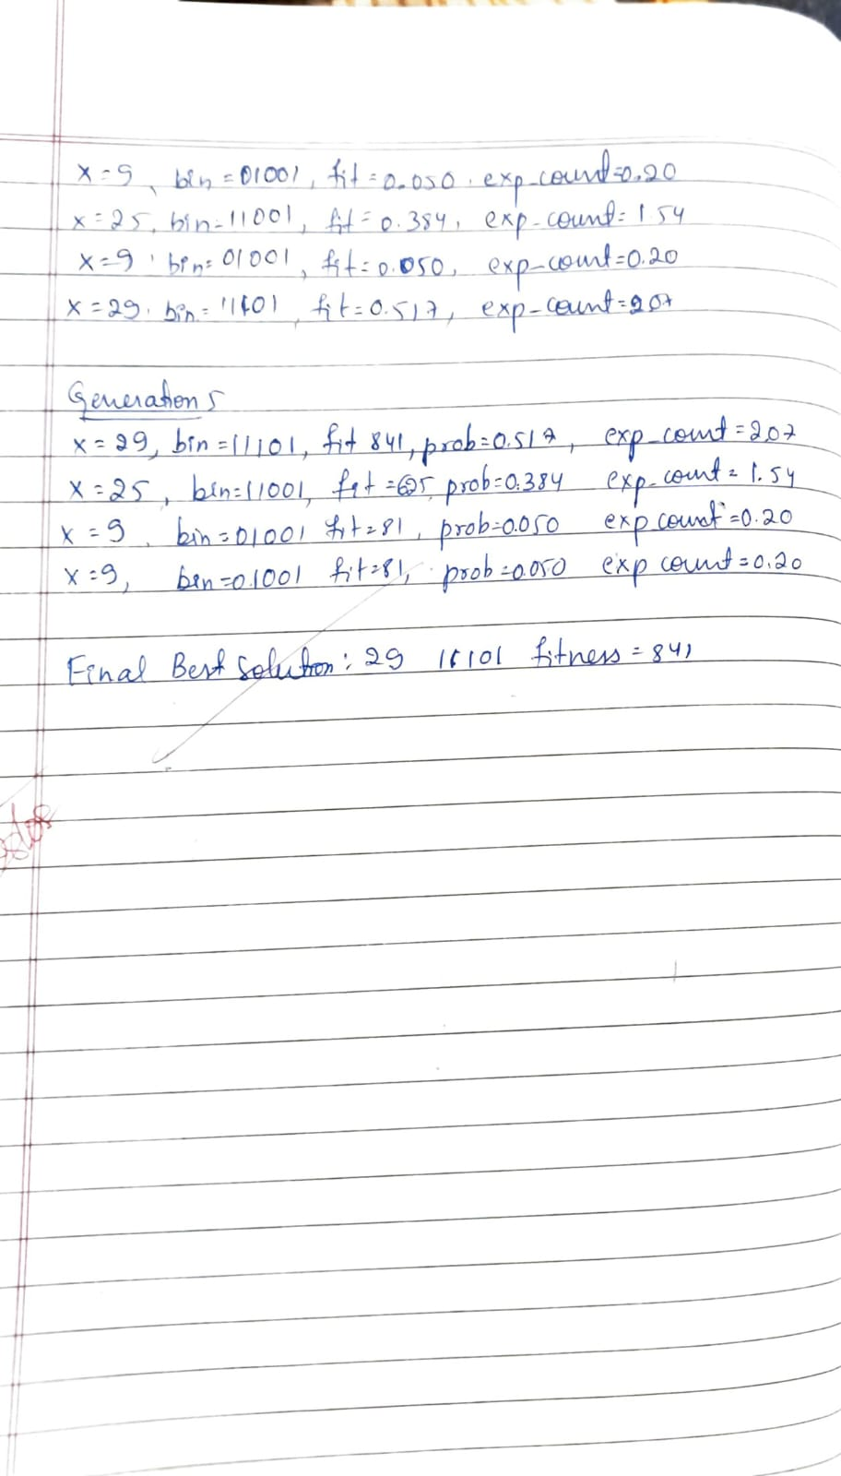

Problem 2
Gene Expression Algorithms (GEA) are inspired by the biological process of gene expression in living organisms. This process involves the translation of genetic information encoded in DNA into functional proteins. In GEA, solutions to optimization problems are encoded in a manner similar to genetic sequences. The algorithm evolves these solutions through selection, crossover, mutation, and gene expression to find optimal or near-optimal solutions. GEA is effective for solving complex optimization problems in various domains, including engineering, data analysis, and machine learning

import random

POP_SIZE = 4
CHROM_LENGTH = 5
MAX_GENERATIONS = 5
MUTATION_RATE = 0.1

def gene_expression(chromosome):
return int(chromosome, 2)

def fitness(chromosome):
x = gene_expression(chromosome)
return x * 2* x

def get_population_from_input():
population = []
print(f"Enter {POP_SIZE} chromosomes (each {CHROM_LENGTH} bits, only 0 or 1):")
while len(population) < POP_SIZE:
chrom = input(f"Chromosome {len(population) + 1}: ").strip()
if len(chrom) == CHROM_LENGTH and all(c in '01' for c in chrom):
population.append(chrom)
else:
print(f"Invalid chromosome! Please enter exactly {CHROM_LENGTH} bits (0 or 1).")
return population

def select(population):
fitnesses = [fitness(chrom) for chrom in population]
total_fitness = sum(fitnesses)
pick = random.uniform(0, total_fitness)
current = 0
for i, chrom in enumerate(population):
current += fitnesses[i]
if current > pick:
return chrom

def crossover(parent1, parent2):
point = random.randint(1, CHROM_LENGTH - 1)
child1 = parent1[:point] + parent2[point:]
child2 = parent2[:point] + parent1[point:]
return child1, child2

def mutate(chromosome):
mutated = ''
for bit in chromosome:
if random.random() < MUTATION_RATE:
mutated += '1' if bit == '0' else '0'
else:
mutated += bit
return mutated

def genetic_algorithm():
population = get_population_from_input()
print(f"Initial Population: {population}")

best_overall = None
best_fitness = float('-inf')

for generation in range(MAX_GENERATIONS):
new_population = []
while len(new_population) < POP_SIZE:
parent1 = select(population)
parent2 = select(population)
child1, child2 = crossover(parent1, parent2)
child1 = mutate(child1)
child2 = mutate(child2)
new_population.extend([child1, child2])

population = new_population[:POP_SIZE]

best = max(population, key=fitness)
best_fit = fitness(best)
if best_fit > best_fitness:
best_fitness = best_fit
best_overall = best

print(f"Generation {generation + 1}: Best Chromosome = {best}, "
f"Expressed Value = {gene_expression(best)}, Fitness = {best_fit}")

print(f"\nBest solution after {MAX_GENERATIONS} generations: {best_overall} "
f"with expressed value = {gene_expression(best_overall)} and fitness = {best_fitness}")

if __name__ == "__main__":
genetic_algorithm()
OUTPUT:
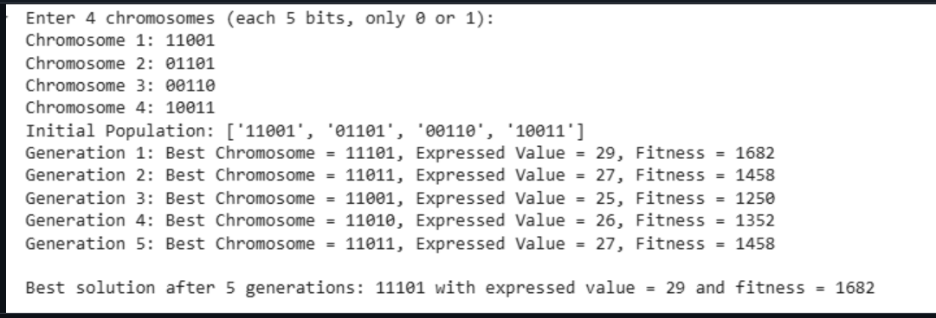
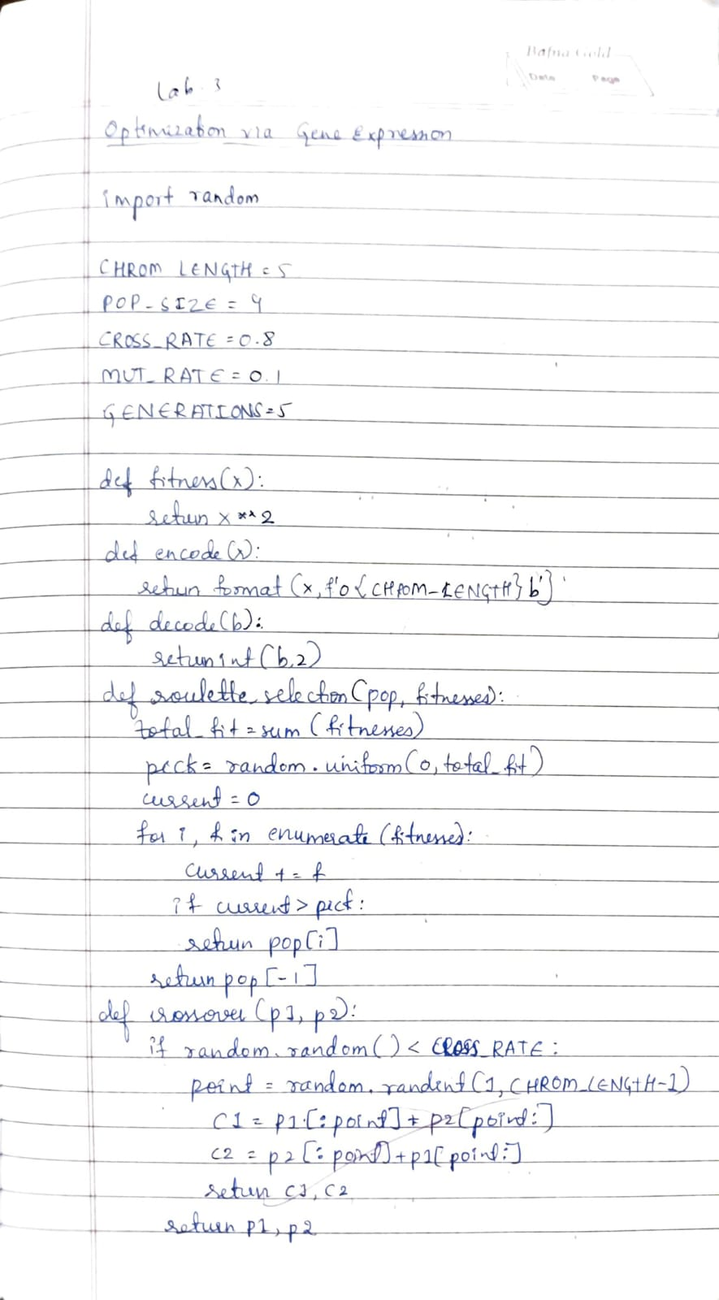
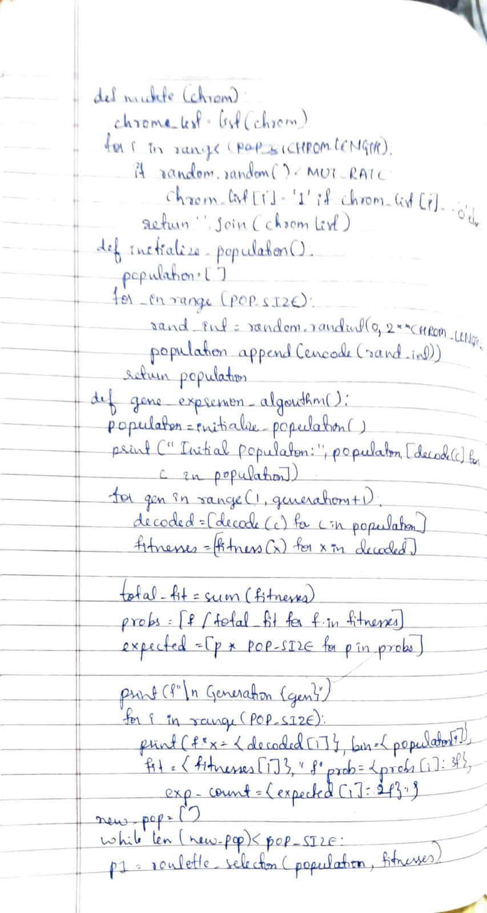
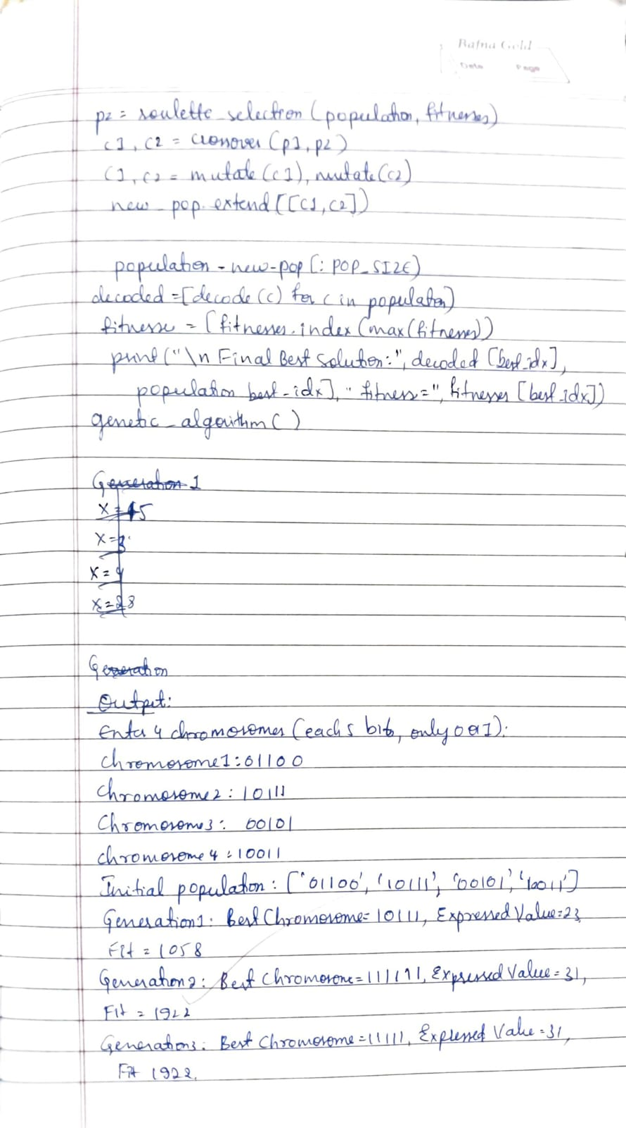
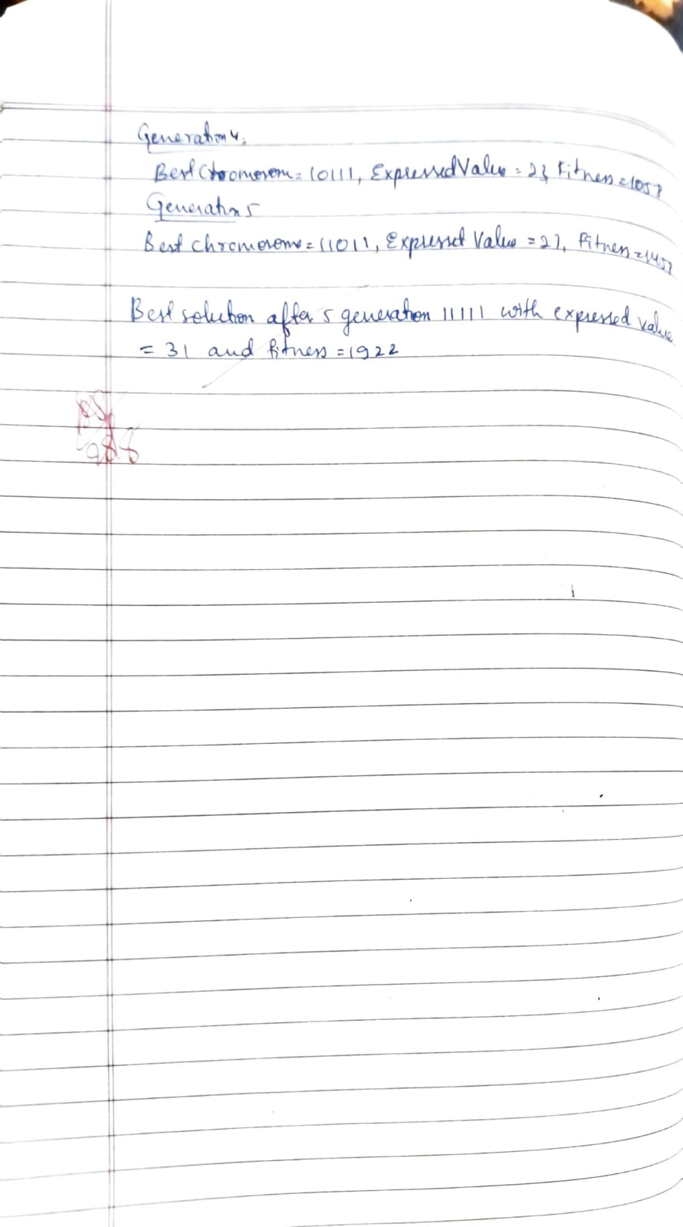
Problem 3
Particle Swarm Optimization (PSO) is inspired by the social behavior of birds flocking or fish schooling. PSO is used to find optimal solutions by iteratively improving a candidate solution with regard to a given measure of quality. Implement the PSO algorithm using Python to optimize a mathematical function.

import numpy as np

num_drones = 5
area_size = 20
num_particles = 30
iterations = 10

w = 0.5
c1 = 1.5
c2 = 1.5

dim = num_drones * 2

particles = np.random.uniform(0, area_size, (num_particles, dim))
velocities = np.zeros((num_particles, dim))

pbest_positions = particles.copy()
pbest_scores = np.full(num_particles, -np.inf)

gbest_position = None
gbest_score = -np.inf

def fitness(position):
x = np.sum(position)
return (x*2 + 5*x + 20)

for iter in range(iterations):
for i in range(num_particles):
score = fitness(particles[i])

if score > pbest_scores[i]:
pbest_scores[i] = score
pbest_positions[i] = particles[i].copy()

if score > gbest_score:
gbest_score = score
gbest_position = particles[i].copy()

r1, r2 = np.random.rand(), np.random.rand()
for i in range(num_particles):
velocities[i] = (w * velocities[i] +
c1 * r1 * (pbest_positions[i] - particles[i]) +
c2 * r2 * (gbest_position - particles[i]))

particles[i] += velocities[i]
particles[i] = np.clip(particles[i], 0, area_size-1)

print(f"Iteration {iter}, Best Fitness: {gbest_score:.2f}")

print("\nOptimized drone waypoints (x,y):")
optimized_coords = gbest_position.reshape((num_drones, 2))
for idx, coord in enumerate(optimized_coords):
print(f"Drone {idx+1}: {coord}")
OUTPUT:
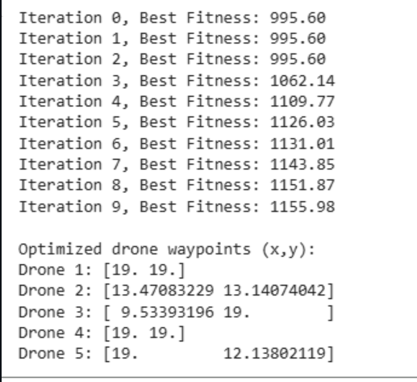

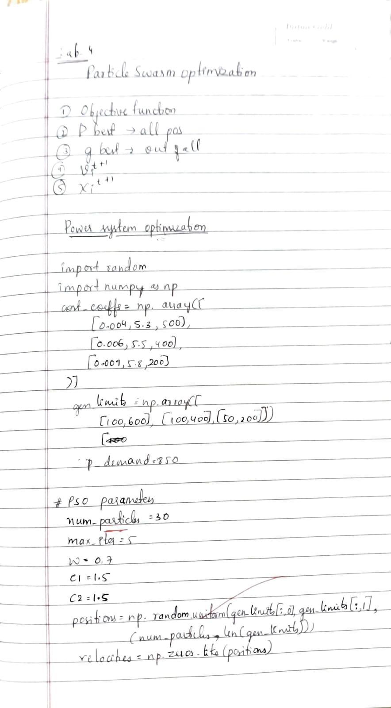
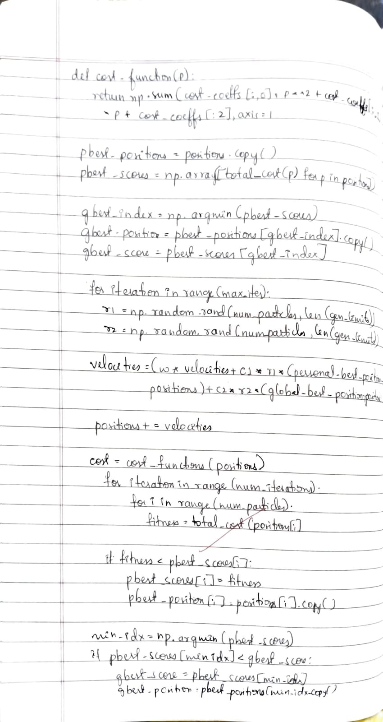
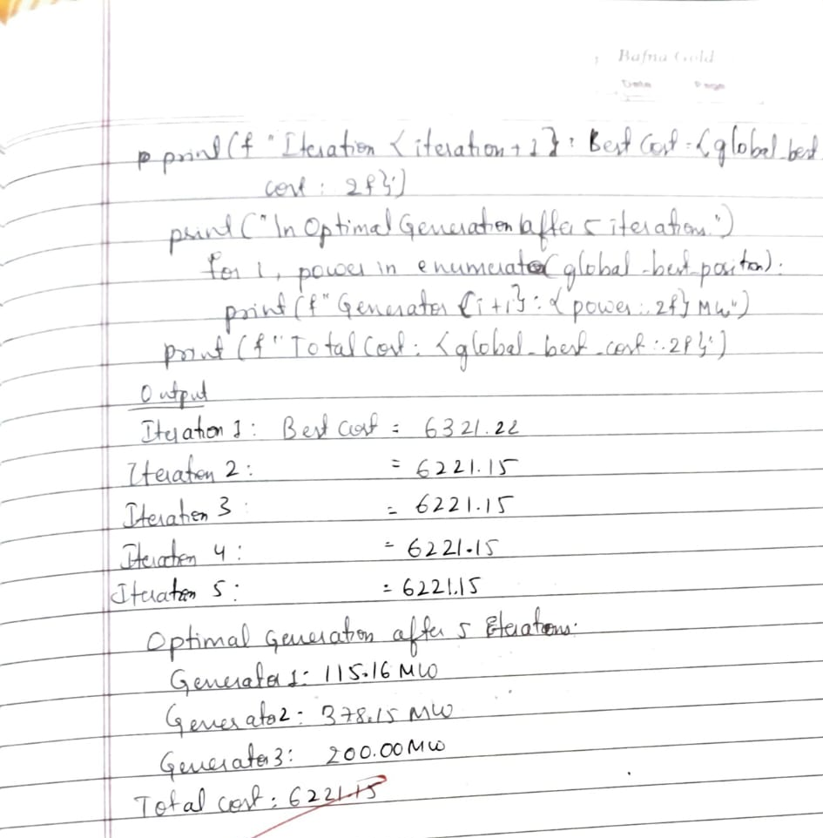

Problem 4
The foraging behavior of ants has inspired the development of optimization algorithms that can solve complex problems such as the Traveling Salesman Problem (TSP). Ant Colony Optimization (ACO) simulates the way ants find the shortest path between food sources and their nest. Implement the ACO algorithm using Python to solve the TSP, where the objective is to find the shortest possible
import numpy as np
import random

NUM_ANTS =2
NUM_ITERATIONS = 50
ALPHA = 1.0
BETA = 5.0
EVAPORATION = 0.5
Q = 100

def input_matrix(name):
print(f"Enter the {name} matrix row by row (space-separated). Type 'done' when finished:")
matrix = []
while True:
row = input()
if row.strip().lower() == 'done':
break
row_values = list(map(float, row.strip().split()))
matrix.append(row_values)
return np.array(matrix)

print("Input Cost Matrix (Distance Matrix):")
dist_matrix = input_matrix("cost")
NUM_CITIES = len(dist_matrix)

print("\nInput Initial Pheromone Matrix:")
pheromone = input_matrix("pheromone")

assert dist_matrix.shape == (NUM_CITIES, NUM_CITIES), "Cost matrix must be square."
assert pheromone.shape == (NUM_CITIES, NUM_CITIES), "Pheromone matrix must be square."

best_distance = float('inf')
best_path = []

for iteration in range(NUM_ITERATIONS):
all_paths = []
all_distances = []

for ant in range(NUM_ANTS):
path = [random.randint(0, NUM_CITIES - 1)]

while len(path) < NUM_CITIES:
current_city = path[-1]
probabilities = []

for next_city in range(NUM_CITIES):
if next_city not in path:
tau = pheromone[current_city][next_city] ** ALPHA
eta = (1 / dist_matrix[current_city][next_city]) ** BETA
probabilities.append(tau * eta)
else:
probabilities.append(0)

probabilities = np.array(probabilities)
probabilities_sum = probabilities.sum()
if probabilities_sum == 0:
break
probabilities /= probabilities_sum

next_city = np.random.choice(range(NUM_CITIES), p=probabilities)
path.append(next_city)

if len(path) < NUM_CITIES:
continue

path.append(path[0])
distance = sum(dist_matrix[path[i]][path[i + 1]] for i in range(NUM_CITIES))
all_paths.append(path)
all_distances.append(distance)

if distance < best_distance:
best_distance = distance
best_path = path

pheromone *= (1 - EVAPORATION)

for i in range(len(all_paths)):
for j in range(NUM_CITIES):
from_city = all_paths[i][j]
to_city = all_paths[i][j + 1]
pheromone[from_city][to_city] += Q / all_distances[i]
pheromone[to_city][from_city] += Q / all_distances[i]

if iteration % 10 == 0 or iteration == NUM_ITERATIONS - 1:
print(f"Iteration {iteration}: Best Distance = {best_distance:.2f}")

print("\nBest Path Found:")
print(" -> ".join(map(str, best_path)))
print(f"Total Distance: {best_distance:.2f}")
OUTPUT:
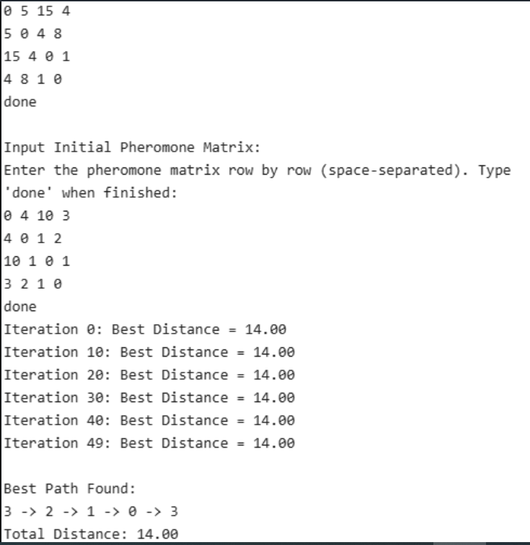
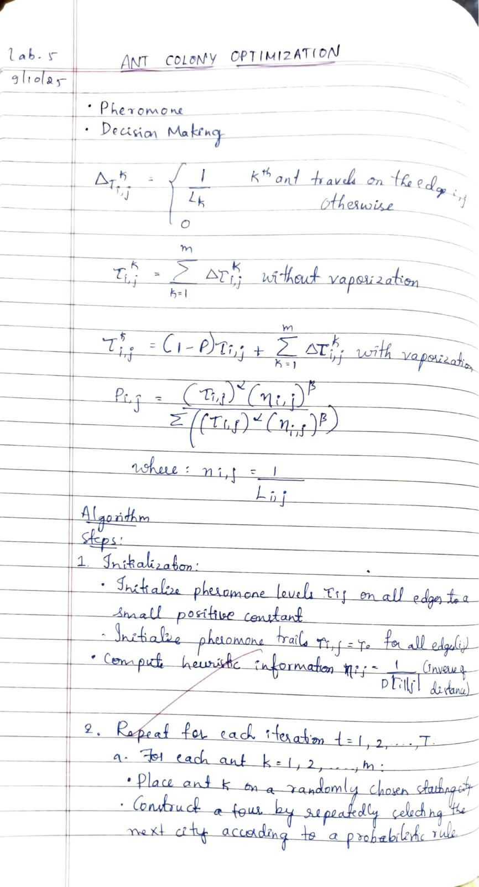
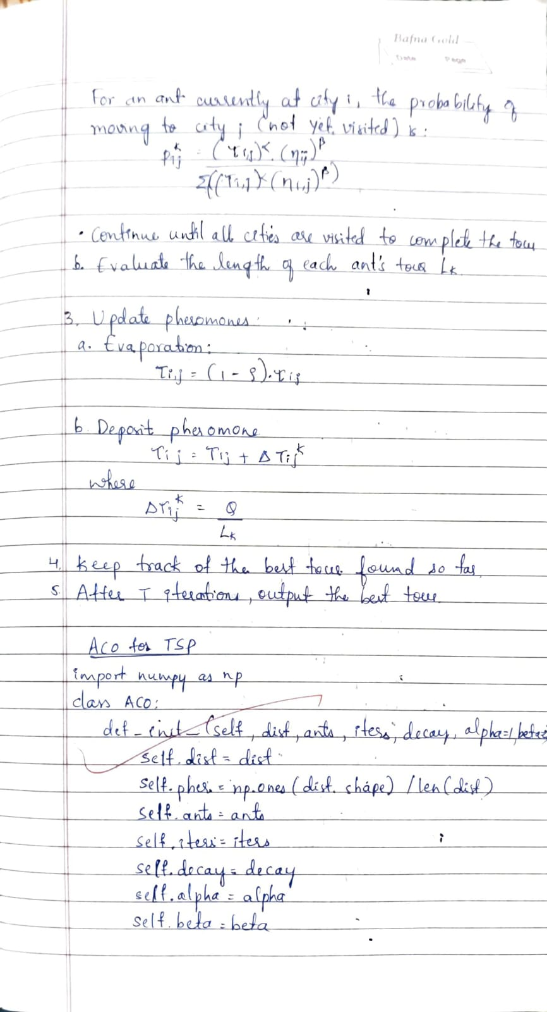
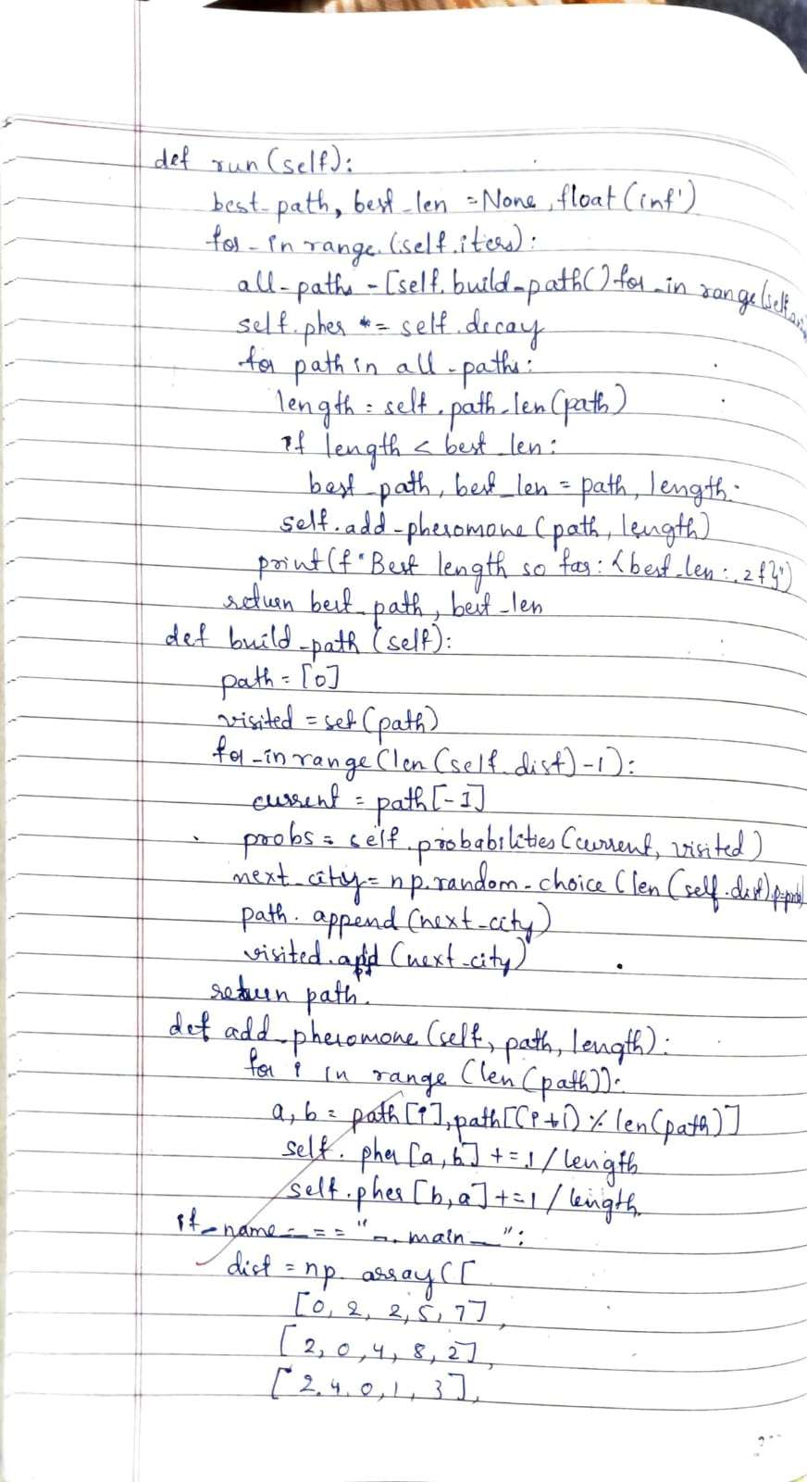
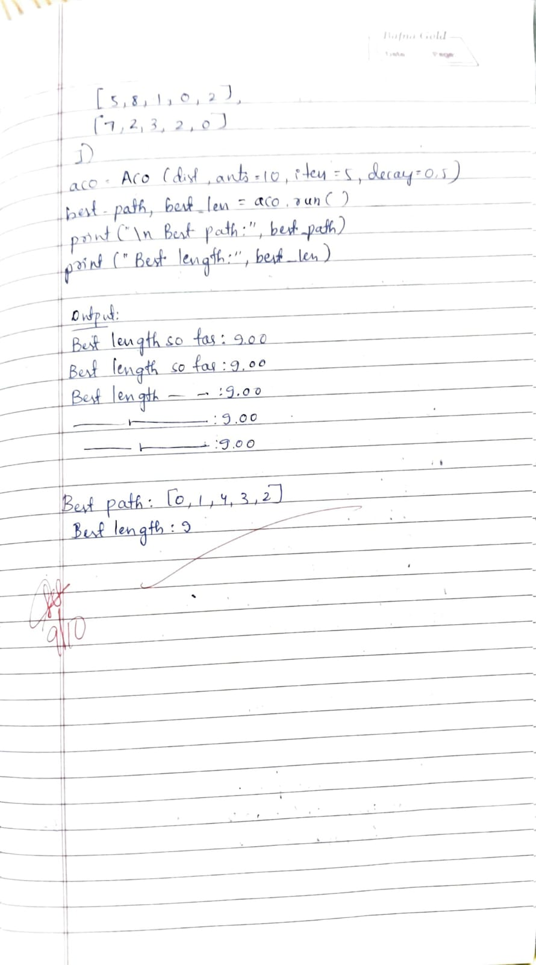
Problem 5
Cuckoo Search (CS) is a nature-inspired optimization algorithm based on the brood parasitism of some cuckoo species. This behavior involves laying eggs in the nests of other birds, leading to the optimization of survival strategies. CS uses Lévy flights to generate new solutions, promoting global search capabilities and avoiding local minima. The algorithm is widely used for solving continuous optimization problems and has applications in various domains, including engineering design, machine learning, and data mining
import random
import math

weights = [10, 20, 30, 40, 15, 25, 35]
values = [60, 100, 120, 240, 80, 150, 200]
capacity = 100

n_items = len(weights)
n_nests = 15
max_iter = 50
pa = 0.25

def fitness(solution):
total_weight = sum(w for w, s in zip(weights, solution) if s == 1)
total_value = sum(v for v, s in zip(values, solution) if s == 1)
if total_weight > capacity:
return 0
else:
return total_value

def generate_nest():
return [random.randint(0, 1) for _ in range(n_items)]

def levy_flight(Lambda=1.5):
sigma_u = (math.gamma(1 + Lambda) * math.sin(math.pi * Lambda / 2) /
(math.gamma((1 + Lambda) / 2) * Lambda * 2 ** ((Lambda - 1) / 2))) ** (1 / Lambda)
u = random.gauss(0, sigma_u)
v = random.gauss(0, 1)
step = u / (abs(v) ** (1 / Lambda))
return step

def get_cuckoo(nest, best_nest):
new_nest = []
for xi, bi in zip(nest, best_nest):
step = levy_flight()
val = xi + step * (xi - bi)

s = 1 / (1 + math.exp(-val))
new_val = 1 if s > 0.5 else 0
new_nest.append(new_val)
return new_nest

def cuckoo_search():
nests = [generate_nest() for _ in range(n_nests)]
fitness_values = [fitness(nest) for nest in nests]

best_index = fitness_values.index(max(fitness_values))
best_nest = nests[best_index][:]
best_fitness = fitness_values[best_index]

for iteration in range(1, max_iter + 1):
for i in range(n_nests):
new_nest = get_cuckoo(nests[i], best_nest)
new_fitness = fitness(new_nest)
if new_fitness > fitness_values[i]:
nests[i] = new_nest
fitness_values[i] = new_fitness

for i in range(n_nests):
if random.random() < pa:
nests[i] = generate_nest()
fitness_values[i] = fitness(nests[i])

current_best_index = fitness_values.index(max(fitness_values))
current_best_fitness = fitness_values[current_best_index]

if current_best_fitness > best_fitness:
best_fitness = current_best_fitness
best_nest = nests[current_best_index][:]

if iteration % 10 == 0:
print(f"Iteration {iteration}: Best value so far = {best_fitness}")

return best_nest, best_fitness

if __name__ == "__main__":
best_solution, best_value = cuckoo_search()
total_weight = sum(w for w, s in zip(weights, best_solution) if s == 1)
print(f"\nBest packing solution (1 = selected): {best_solution}")
print(f"Total value of supplies packed: {best_value}")
print(f"Total weight: {total_weight}")
OUTPUT: 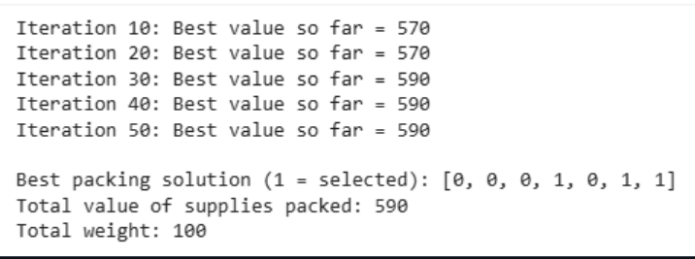
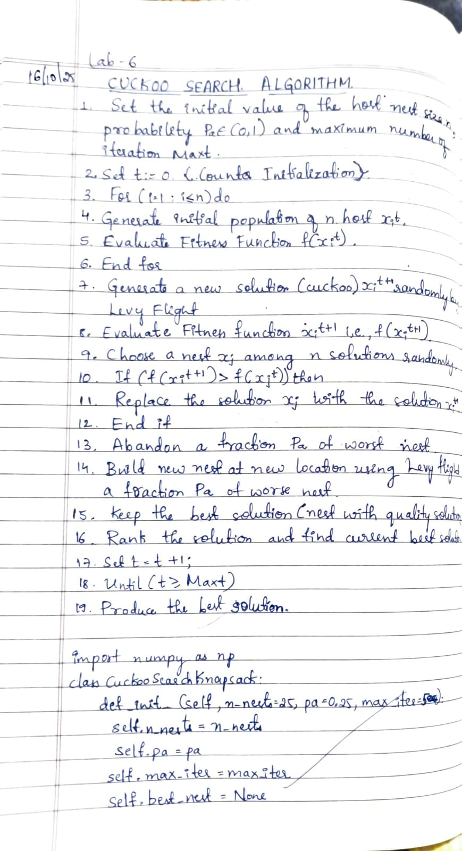
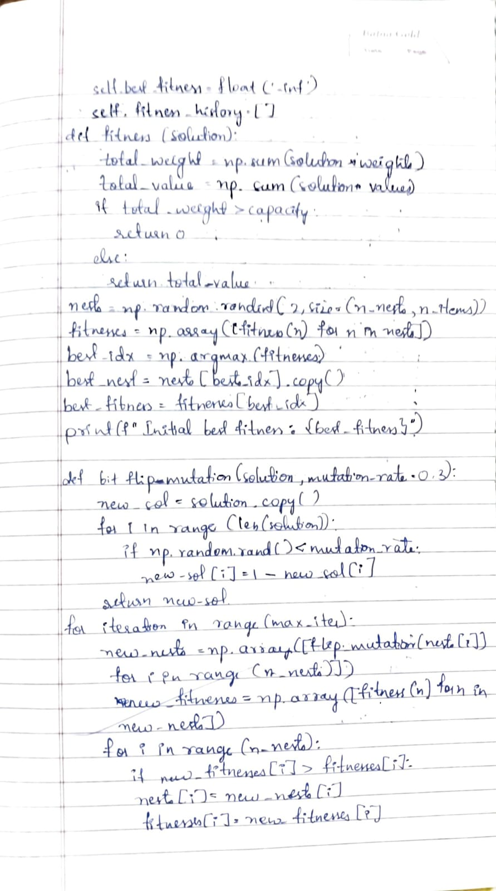
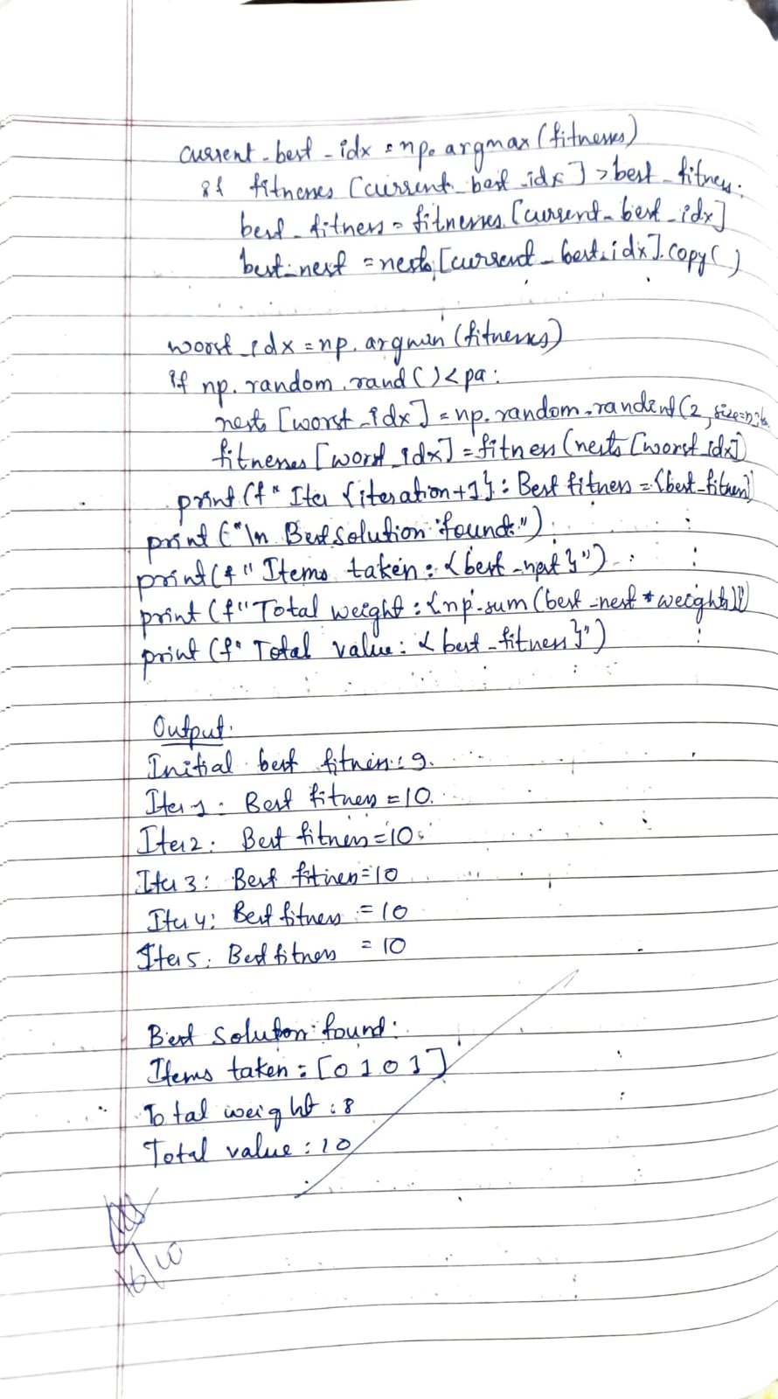

Program 6
The Grey Wolf Optimizer (GWO) algorithm is a swarm intelligence algorithm inspired by the social hierarchy and hunting behavior of grey wolves. It mimics the leadership structure of alpha, beta, delta, and omega wolves and their collaborative hunting strategies. The GWO algorithm uses these social hierarchies to model the optimization process, where the alpha wolves guide the search process while beta and delta wolves assist in refining the search direction. This algorithm is effective for continuous optimization problems and has applications in engineering, data analysis, and machine learning.

import numpy as np
import matplotlib.pyplot as plt

def irrigation_objective(x):
# Parameters for irrigation problem
a = 0.8 # yield penalty factor
b = 5 # water cost factor
x_opt = 60 # optimal irrigation level (e.g., mm/day)
return a * (x - x_opt)**2 + b / x

def GWO(obj_func, lb, ub, dim, n_wolves, max_iter):
# Initialize wolves randomly within bounds
wolves = np.random.uniform(lb, ub, (n_wolves, dim))
alpha, beta, delta = np.zeros(dim), np.zeros(dim), np.zeros(dim)
alpha_score, beta_score, delta_score = float("inf"), float("inf"), float("inf")

convergence_curve = []

for t in range(max_iter):
for i in range(n_wolves):
fitness = obj_func(wolves[i])
# Update alpha, beta, delta
if fitness < alpha_score:
alpha_score, alpha = fitness, wolves[i].copy()
elif fitness < beta_score:
beta_score, beta = fitness, wolves[i].copy()
elif fitness < delta_score:
delta_score, delta = fitness, wolves[i].copy()

# Linearly decreasing 'a' from 2 to 0
a = 2 - t * (2 / max_iter)

# Update positions of wolves
for i in range(n_wolves):
for j in range(dim):
r1, r2 = np.random.rand(), np.random.rand()
A1, C1 = 2 * a * r1 - a, 2 * r2
D_alpha = abs(C1 * alpha[j] - wolves[i][j])
X1 = alpha[j] - A1 * D_alpha

r1, r2 = np.random.rand(), np.random.rand()
A2, C2 = 2 * a * r1 - a, 2 * r2
D_beta = abs(C2 * beta[j] - wolves[i][j])
X2 = beta[j] - A2 * D_beta

r1, r2 = np.random.rand(), np.random.rand()
A3, C3 = 2 * a * r1 - a, 2 * r2
D_delta = abs(C3 * delta[j] - wolves[i][j])
X3 = delta[j] - A3 * D_delta

wolves[i][j] = (X1 + X2 + X3) / 3

# Boundary handling
wolves[i] = np.clip(wolves[i], lb, ub)

convergence_curve.append(alpha_score)

return alpha, alpha_score, convergence_curve

dim = 1
lb, ub = 10, 100 # irrigation limits (mm/day)
n_wolves = 20
max_iter = 50

best_pos, best_score, curve = GWO(irrigation_objective, lb, ub, dim, n_wolves, max_iter)
print(f"Optimal Irrigation Level: {best_pos[0]:.3f} mm/day")
print(f"Minimum Cost Function Value: {float(best_score):.4f}")

plt.plot(curve, 'b-', linewidth=2)
plt.title('GWO Convergence Curve for Irrigation Optimization')
plt.xlabel('Iteration')
plt.ylabel('Fitness (Objective Value)')
plt.grid(True)
plt.show()
OUTPUT:
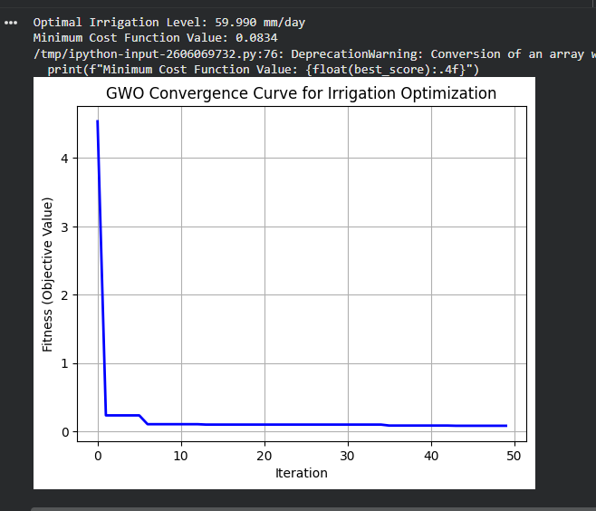

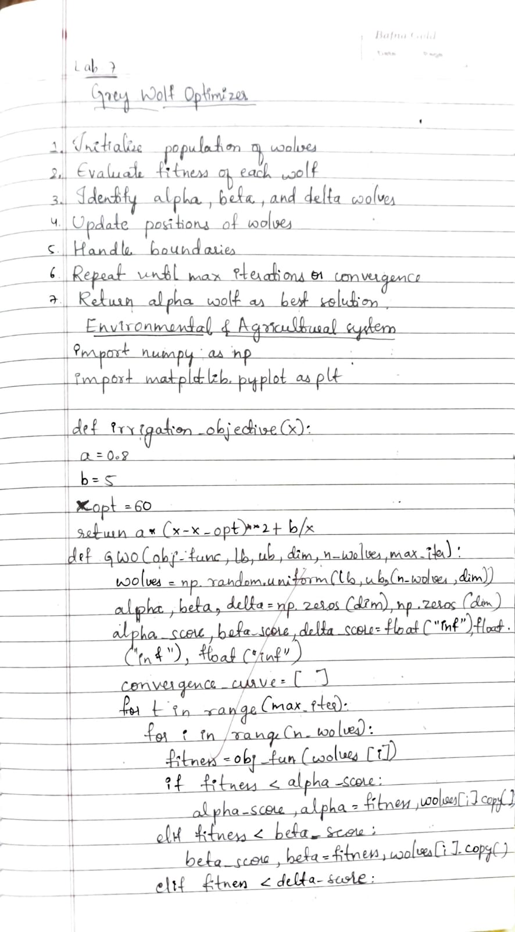
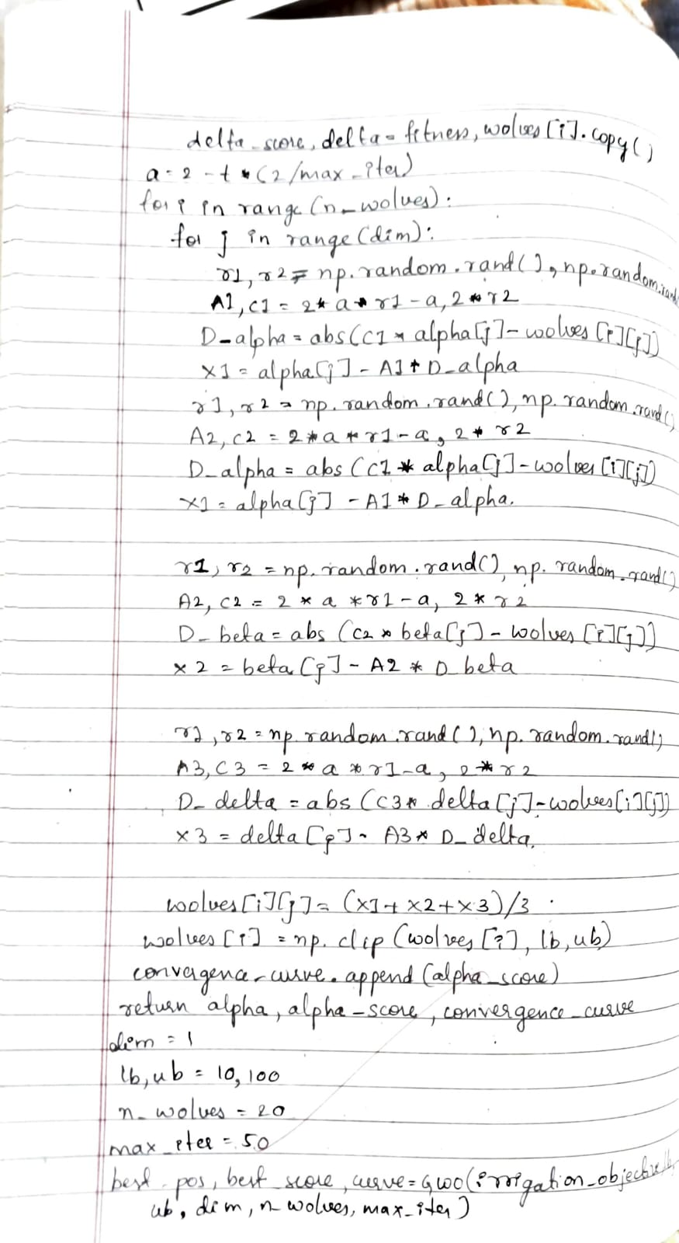
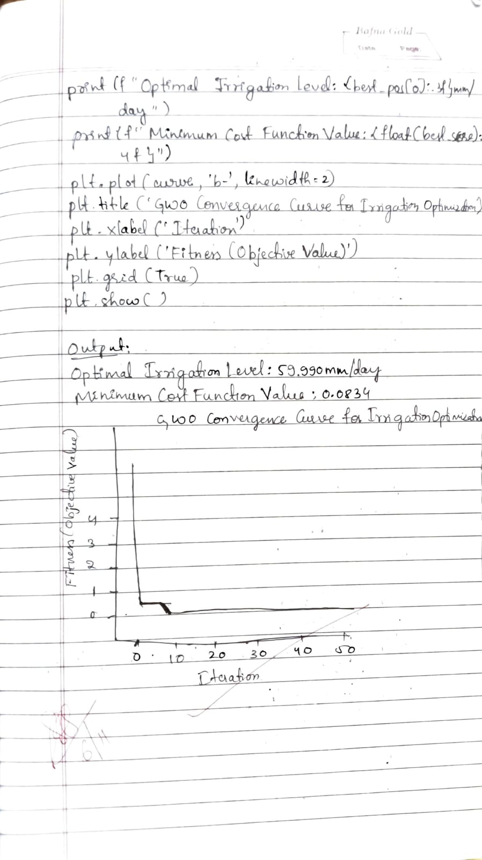

Program 7
Parallel Cellular Algorithms are inspired by the functioning of biological cells that operate in a highly parallel and distributed manner. These algorithms leverage the principles of cellular automata and parallel computing to solve complex optimization problems efficiently. Each cell represents a potential solution and interacts with its neighbors to update its state based on predefined rules. This interaction models the diffusion of information across the cellular grid, enabling the algorithm to explore the search space effectively. Parallel Cellular Algorithms are particularly suitable for large scale optimization problems and can be implemented on parallel computing architectures for enhanced performance.

#PCA
import numpy as np
import random

num_customers = int(input("Enter number of customers (excluding depot): "))
num_vehicles = int(input("Enter number of vehicles: "))

print("\nEnter the distance matrix (including depot 0):")
print(f"Matrix should be {num_customers + 1} x {num_customers + 1}")
distance_matrix = []

for i in range(num_customers + 1):
row = list(map(int, input(f"Row {i+1}: ").split()))
distance_matrix.append(row)

distance_matrix = np.array(distance_matrix)

rows = int(input("\nEnter number of grid rows: "))
cols = int(input("Enter number of grid columns: "))
grid_dim = (rows, cols)
population_size = rows * cols

num_generations = int(input("\nEnter number of generations: "))

def generate_individual():
perm = list(range(1, num_customers + 1))
random.shuffle(perm)
return perm

population = [generate_individual() for _ in range(population_size)]

def fitness(individual):
split_points = np.linspace(0, num_customers, num_vehicles + 1, dtype=int)
total_distance = 0
for i in range(num_vehicles):
route = [0] + individual[split_points[i]:split_points[i+1]] + [0]
for j in range(len(route) - 1):
total_distance += distance_matrix[route[j], route[j+1]]
return total_distance

def get_neighbors(idx):
r, c = divmod(idx, grid_dim[1])
neighbors = []
for dr in [-1, 0, 1]:
for dc in [-1, 0, 1]:
nr, nc = r + dr, c + dc
if 0 <= nr < grid_dim[0] and 0 <= nc < grid_dim[1]:
n_idx = nr * grid_dim[1] + nc
if n_idx != idx:
neighbors.append(n_idx)
return neighbors

def crossover(parent1, parent2):
size = len(parent1)
a, b = sorted(random.sample(range(size), 2))
child = [None] * size
child[a:b] = parent1[a:b]

pointer = b
for gene in parent2[b:] + parent2[:b]:
if gene not in child:
if pointer == size:
pointer = 0
child[pointer] = gene
pointer += 1
return child

def mutate(individual):
a, b = random.sample(range(len(individual)), 2)
individual[a], individual[b] = individual[b], individual[a]
return individual

def pca_iteration(pop):
new_pop = pop.copy()
for idx in range(len(pop)):
neighbors = get_neighbors(idx)
partner_idx = random.choice(neighbors)
parent1 = pop[idx]
parent2 = pop[partner_idx]

child = crossover(parent1, parent2)
if random.random() < 0.2:
child = mutate(child)

if fitness(child) < fitness(pop[idx]):
new_pop[idx] = child
return new_pop

for gen in range(num_generations):
population = pca_iteration(population)
best_fitness = min(fitness(ind) for ind in population)
print(f"Generation {gen+1}: Best total distance = {best_fitness}")

best_individual = min(population, key=fitness)
print("\nBest route assignment (split evenly):")
split_points = np.linspace(0, num_customers, num_vehicles + 1, dtype=int)
for i in range(num_vehicles):
route = [0] + best_individual[split_points[i]:split_points[i+1]] + [0]
print(f"Vehicle {i+1} route: {route}")
print(f"Total distance: {fitness(best_individual)}")
OUTPUT:
